
TASK 5 REPORT
UI DESIGN AND IMPLEMENTATION
CEF440: PROGRAMMING AND MOBILE PROGRAMMING

REPUBLIC OF CAMEROON

PEACE-WORK-FATHERLAND
BUEA, SOUTH WEST REGION
UNIVERSITY OF BUEA

FACULTY OF ENGINEERING AND TECHNOLOGY
(FET)

By:
GROUP 4 MEMBERS

COURSE INSTRUCTOR:

Dr. Engr. NKEMENI VALERY

Name | Matricule
AKO JUNIOR NGOH | FE23A008
ETUMA ELKINGS BOSANGO | FE23A053
MOUKAM HAKO BELLAMY STEVE | FE23A096
NJIKANG BRIGHT NDODE NGONE | FE23A115
RINGNYU MBUNWE GIYOH LEMUEL | FE23A136
Table of Contents
1. INTRODUCTION 3
2. APP IDENTITY 4
2.1 Product Naming and Branding 4
2.2 Core Value Proposition 4
2.3 Target User Personas 4
3. VISUAL DESIGN (FIGMA) 5
3.1 Wireframes and Design Methodology 5
3.2 Colour Palette, Typography, and System Styling 5
3.3 Detailed Screen Mockups and User Flows 5
4. FRONTEND IMPLEMENTATION 11
4.1 The Mobile Development Paradigm Shift 11
4.2 Expo as the Architectural Foundation 11
4.3 Project Architecture and File Structure 11
4.3.1 MVVM Architecture 12
4.4 TypeScript Interface Definitions 12
4.5 Routing and Navigation 13
4.6 Responsive Layout Styling and Hardware Optimisation 14
4.7 Quick View of the Frontend 15
4.8 Development Challenges 16
5. CONCLUSION 17
6.REFERENCES 18

INTRODUCTION

This report presents the architectural design, user experience (UX) mapping, and frontend implementation of the Quality of Experience (QoE) Mobile Network Monitoring Application called SpeeDT. This phase of the project builds on the requirements analysis and system design completed in the previous tasks and focuses on transforming those ideas into a working mobile application.
The development of SpeeDT was influenced by the challenges commonly faced by mobile network users in Cameroon. These challenges include unstable network connections, sudden signal loss, poor network coverage in some areas, and concerns about battery consumption and mobile data usage. Since the application is intended for both Android and iOS users, it was important to design a solution that would work efficiently across different devices while remaining lightweight and easy to use.
To design the user interface, Figma was used to create wireframes and visual prototypes before the actual development process began. The frontend implementation was then carried out using React Native with Expo, alongside TypeScript and JavaScript. This allowed the application to be developed for multiple platforms from a single codebase. In addition, the application follows the Model-View-ViewModel (MVVM) architecture, which helps keep the code organized, easier to maintain, and scalable for future improvements. Through this approach, SpeeDT is able to provide users with network performance information while supporting the collection of crowdsourced data from different locations across the country.

APP IDENTITY

2.1 Product Naming and Branding
The Quality of Experience (QoE) Mobile Network Monitoring Application is named SpeeDT. The name was chosen to reflect the application's main purpose, which is to monitor network performance and provide users with information about the quality of their mobile network connection. By collecting and analyzing network data, the application helps users better understand the performance of their service provider in different locations.
The visual identity of SpeeDT was designed to be simple, clear, and professional. Elements such as the logo, typography, and overall interface were selected to create a sense of trust and reliability while maintaining a modern appearance. Since the application is intended for a wide range of users, including both everyday mobile subscribers and individuals with technical knowledge, the design focuses on presenting information in a way that is easy to understand while still providing useful network details.
A minimalist design approach was adopted to avoid unnecessary complexity and to ensure that users can quickly access the information they need. This helps improve usability and creates a consistent user experience across the application. Overall, the SpeeDT brand aims to represent accuracy, reliability, and simplicity in mobile network monitoring.

2.2 Core Value Proposition
SpeeDT was developed to help users better understand the quality of their mobile network connection. Many mobile subscribers experience slow internet speeds, unstable connections, and frequent signal loss without knowing the cause. The application addresses this problem by providing useful network information in a simple and accessible way.
The application offers two main benefits:
• It collects anonymous network measurements that can help telecom operators and regulators better understand network performance in different areas.
• It provides users with real-time network information, historical performance records, and alerts that help them monitor the quality of their connection.

2.3 Target User Personas
Based on our requirements analysis, the application was designed for three main categories of users:
• Regular Mobile Users: These include students, traders, and professionals who want a simple way to check the quality of their network connection. They mainly rely on clear indicators and notifications.
• Technical Users: These include networking students, technicians, and engineers who may require more detailed information such as signal strength, latency, and network generation.
• Researchers and Regulators: These users may use the collected data to analyse network coverage and evaluate service quality while ensuring that user privacy is respected.

VISUAL DESIGN (FIGMA)

The visual design of the application was created using Figma, which served as the main UI/UX design and prototyping tool. Figma allowed the team to design the application's layout, create detailed interface mockups, and build interactive prototypes before the development process began.
Using prototypes made it possible to test how users would interact with the application and identify potential design or usability issues at an early stage. This helped the team make improvements before implementation, reducing development difficulties and ensuring a smoother user experience. Overall, Figma played an important role in transforming the initial ideas into a clear and user-friendly design.

3.1 Wireframes and Design Methodology
The visual structure was developed within Figma using a mobile-first, user-centric design pipeline. Structural screens were derived directly from the functional requirements defined in Section 4.2 of the SRS. Low-fidelity layouts were tested to minimise click depth, ensuring that primary telemetry windows, historical sub-graphs, and explicit privacy toggles are accessible within two taps from the primary landing node.
Figma also allowed the team to visualise user interactions, test navigation flows, and gather feedback on design decisions before development. Consistency was maintained across all screens through standardised typography, spacing, icons, and layout structures.

3.2 Colour Palette, Typography, and System Styling
The design system employs a clean, high-contrast aesthetic designed to minimise cognitive overhead and prioritise readability in bright outdoor environments common in the Cameroonian context.
Design Element | Specification | Rationale & Accessibility Compliance
Typography | System Sans-Serif (Inter / Roboto / SF Pro) | Ensures optimal screen legibility, native device rendering speeds, and modern UI clean aesthetics across mobile viewports.
Primary Surface | Crisp white (#FFFFFF) for all primary screen backgrounds. | Maximizes contrast against text elements during outdoor ambient glare.
Dividers & Borders | Mid-tone grey (#808080) | Provides soft structural separation between metrics without cluttering the viewport
Primary Text | Pure black (#000000) for all body copy and headings. | Guarantees strict compliance with WCAG contrast ratios for text readability.
Status Indicators | High-contrast shading patterns and inverted text. | Avoids colour-only coding for accessibility compliance, protecting users with colour-vision deficiencies.

3.3 Detailed Screen Mockups and User Flows
Five core operational screens were mapped out within Figma, each matching the interface specifications of the product requirements:

Screen 1: Onboarding & Welcome
Core Objective: Introduces the application to first-time users and communicates the SpeeDT value proposition before navigating to the consent flow.
- Displays the application name, tagline ("Understand Your Network Like Never Before"), and a brief description.
- Presents three feature preview blocks: Real-Time Monitoring, Smart Alerts, and Contribute Anonymously.
- A prominent "Get Started" call-to-action button navigates the user to the Consent screen.
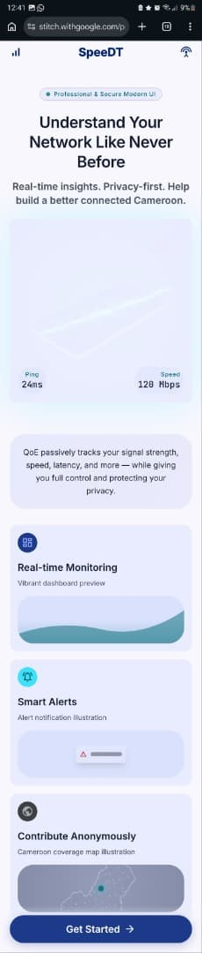
Figure 1: Onboarding Screen SpeeDT Welcome & Feature Overview

Screen 2: Consent & Permissions
Core Objective: Handles first-launch device registration and ART-compliant user authorisation before initialising any backend threads.
- Features a shield icon header and the heading "Before We Begin".
- Presents three granular permission toggles: (a) Background Network Metrics Collection, (b) GPS Location for Coverage Mapping, and (c) Occasional QoE Feedback Prompts.
- No passive logging background service can be instantiated until the user explicitly confirms consent.
- Includes a link to the full Privacy Policy for transparency.
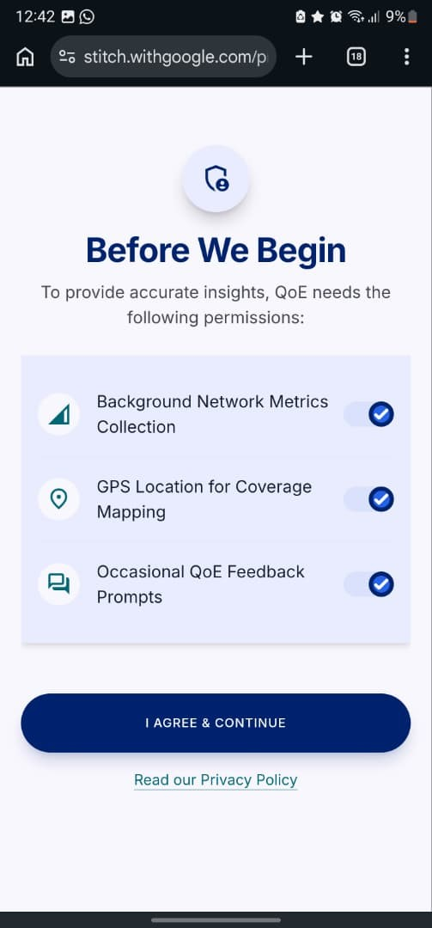
Figure 2: Consent Screen Permissions & Privacy Agreement

Screen 3: Real-Time Dashboard (Home)
Core Objective: Displays live diagnostic readouts of network performance indicators.
- Top section: an animated circular download speed gauge (Mbps) with upload speed and ping displayed below.
- Network Status card: qualitative connectivity label (e.g., "Connected 5G Ultra Wideband") with a live status dot.
- Reliability Score card: a numeric score out of 100 with a visual progress bar.
- Recent Tests list: location, timestamp, and measured speed for recent measurements, accessible within one scroll.
- A floating action button triggers a manual speed test on demand.
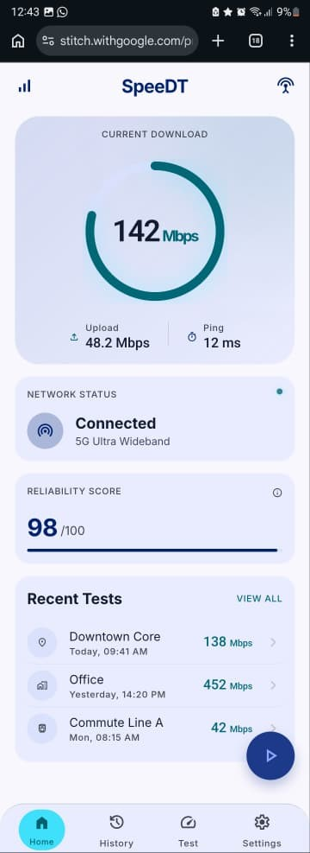
Figure 3: Home Dashboard Real-Time Network Metrics

Screen 4: Performance History
Core Objective: Provides users with clear historical data regarding their connection quality, building trust and transparency.
- Displays a 7-day trend chart plotting download speed and signal strength over time.
- Summary metrics display average download speed and peak recorded performance.
- A log list details each recorded event with location, timestamp, network generation, and speed.
- No-service events are clearly flagged with a distinct icon and label.
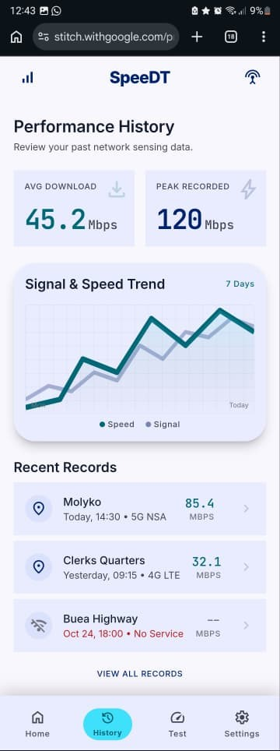
Figure 4: History Screen Performance Trends & Measurement Log

Screen 5: Privacy & Application Settings
Core Objective: Gives the user complete control over their data, aligning with local regulatory standards.
- Contains toggle rows to reconfigure consent states: Background Monitoring, Location Services, and Feedback Prompts.
- Displays exact app resource footprints (battery drain percentage, mobile data consumed).
- Includes a prominent "Purge All Device Data" destructive action that clears local storage and fires a remote deletion request.
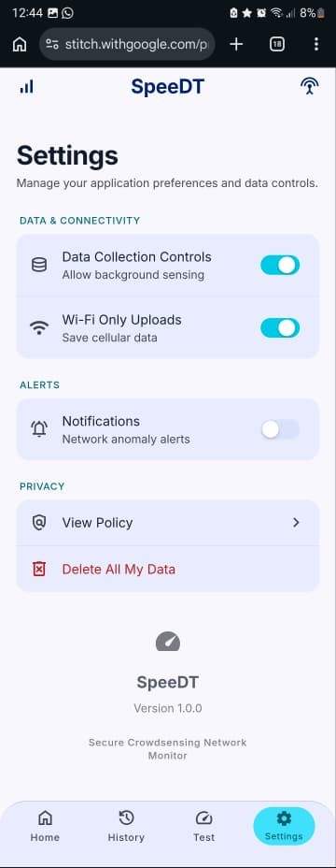
Figure 5: Settings Screen Privacy Controls & App Configuration

FRONTEND IMPLEMENTATION

4.1 The Mobile Development Paradigm Shift
Developing a mobile application is different from developing a website because mobile apps must work on different devices and operating systems. We also had to consider factors such as different screen sizes, device capabilities, and how the application behaves when it is opened, running in the background, or temporarily closed by the operating system.
To develop the SpeeDT frontend, we used React Native with Expo because it allowed us to build the application for both Android and iOS using a single codebase. JavaScript and TypeScript were used as the main programming languages due to their flexibility and ease of development. For the user interface design, we used React Native's StyleSheet API together with NativeWind (a Tailwind CSS port for React Native) to create a clean, responsive, and consistent appearance across different mobile devices.

4.2 Expo as the Architectural Foundation
Expo acts as an architectural wrapper for React Native in much the same way that Next.js enhances React for the web providing a streamlined development environment while extending the capabilities of the underlying framework. It handles complex native build files, asset pipelines, and bundling configurations out of the box, allowing developers to focus on writing clean feature logic rather than managing platform toolchains.
Key advantages of the Expo framework as used in SpeeDT:
- Rapid application development and testing via the Expo Go ecosystem, which enables instant visual feedback through Fast Refresh over local Wi-Fi.
- Cross-platform compatibility from a single codebase, supporting both Android (54% share) and iOS (46% share) in the target Cameroonian market.
- Simplified access to device APIs and native features through standardised SDK libraries.
- Unified managed workflow for managing application lifecycles, running manual speed probes, and handling local asset storage.
- Easy deployment and preview on physical devices without waiting for full native compile cycles.

4.3 Project Architecture and File Structure
The frontend follows a strict Model-View-ViewModel (MVVM) structural pattern. The codebase is organised into the following primary layers:
SpeedDT/
├── app/ # Core Managed Layer & Expo Router Pages
│ ├── (tabs)/ # Tab-based navigation layout route group
│ │ ├── home.tsx # Dashboard Endpoint (Real-Time Telemetry)
│ │ ├── history.tsx # Metric Logs & Chart Analytic Endpoint
│ │ ├── test.tsx # Manual Network Speed Probe Endpoint
│ │ └── settings.tsx # App Configurations & Privacy Controls
│ ├── index.tsx # Application Initial Onboarding Root
│ └── consent.tsx # ART Regulation-Compliant Consent Portal
├── screens/ # Decoupled Presentation UI Components
│ ├── onboarding-screen.tsx # Welcome Sliders Layout UI
│ ├── consent-screen.tsx # Permission Toggles Layout UI
│ ├── home-screen.tsx # Active Telemetry Layout UI
│ ├── history-screen.tsx # Analytic Visualizations Layout UI
│ ├── test-screen.tsx # Manual Testing Engine Layout UI
│ └── settings-screen.tsx # Destructive/Config Forms Layout UI
├── components/ # Shared Atomic Component Library
│ ├── onboarding/ # Contextual Onboarding Feature Blocks
│ ├── consent/ # Granular Consent Permission Elements
│ └── ui/ # Primitives (Buttons, Icons, Typography)
├── navigation/ # Type System Route Definitions
│ └── routes.ts # Sealed Immutable Path Objects
└── constants/ # Structural Styling Infrastructure
└── theme.ts
This structure improves maintainability, scalability, and code readability while supporting future feature expansion.

4.3.1 MVVM Architecture
The SpeeDT application follows the Model-View-ViewModel (MVVM) architecture to improve code organization and maintainability.
• Model: Responsible for storing and managing network data collected by the application.
• View: Represents the user interface screens displayed to users, such as the Home, History, Test, and Settings screens.
• ViewModel: Acts as the link between the Model and the View. It processes data and prepares it for display on the user interface.
This separation of responsibilities makes the application easier to maintain, test, and expand in future development stages.

4.4 TypeScript Interface Definitions

Network Metric Data Model
To store and manage network performance information collected by the application, we created a NetworkMetric data model. This model defines the main parameters recorded during each network measurement session. Each record is uniquely identified and includes information about network quality, signal strength, latency, packet loss, and the user's approximate location.
The data collected by this model is summarized in Table below.
Field schema | Native type | Technical operational description
id | string | Unique tracking transaction ID assigned to every data probe instance.
timestamp | string | Date/time stamp string indicating exact data-collection event execution.
carrierName | enum | Active local network connection identifier.
networkGeneration | enum | Real-time cellular technology generation tier.
rsrp | number | null | Signal performance metric. Set to null due to Apple CoreTelephony framework restrictions.
rssi | number | null | Aggregate signal strength baseline value. Set to null under restricted framework parameters.
sinr | number | null | Received background signal noise performance ratio. Set to null on sandboxed subsystems.
latencyPingMs | number | Application network packet processing response delay, measured in milliseconds.
packetLossPercentage | number | Percentage of failed network transit data frames, calculated from 0% to 100%.
districtLocation | string | null | Geospatial context tracking data, localized to district levels for anonymity.

This data model allows the application to collect meaningful network performance metrics while ensuring that sensitive user information is not exposed.
export interface NetworkMetric {
id: string; // Unique session execution GUID
timestamp: string; // High-precision clock entry in ISO 8601
carrierName: "MTN" | "Orange" | "CAMTEL" | "Unknown"; // Active Network Provider
networkGeneration: "2G" | "3G" | "4G" | "5G" | "No Service"; // Air Interface Generation
rsrp: number | null; // Reference Signal Received Power (dBm) [Nullable on iOS]
rssi: number | null; // Received Signal Strength Indicator (dBm) [Nullable on iOS]
sinr: number | null; // Signal-to-Interference-plus-Noise Ratio (dB) [Nullable on iOS]
latencyPingMs: number; // Rounded network round-trip time delay
packetLossPercentage: number; // Failed packet transit delivery integrity factor
districtLocation: string | null; // Spatial context restricted to district granularity
}

Components are built as modular, reusable elements. The Dashboard interface pulls from a useNetworkState hook that exposes clean tracking values. Local UI states utilise lightweight React Context providers to coordinate user consent statuses globally across screens.

4.5 Routing and Navigation
Application Navigation Structure
To manage movement between different sections of the application, we defined a routing structure that specifies the paths for each screen. This routing system helps users navigate smoothly through the application and ensures that each screen can be accessed using a unique route.
The main routes used in the application are shown in Table below.

Navigation Route | Technical Endpoint Key | Screen Target Layout | Functional Pipeline Objective
/ | onboarding | onboarding-screen.tsx | App entry point presenting application value parameters to new clients.
/consent | consent | consent-screen.tsx | Dedicated view for collecting explicit ART regulatory authorization credentials.
/(tabs)/home | tabs.home | home-screen.tsx | Primary workspace view displaying network speed parameters.
/(tabs)/history | tabs.history | history-screen.tsx | Analytics window rendering sequential data history parameters.
/(tabs)/test | tabs.test | test-screen.tsx | Interactive diagnostic window executing active probe calls on demand.
/(tabs)/settings | tabs.settings | settings-screen.tsx | Operations panel containing memory optimization toggles and purge mechanisms.

We organized the main application screens using a tab-based navigation system. This allows users to switch easily between the Home, History, Test, and Settings screens while maintaining a simple and consistent user experience throughout the application.
export const routes = { onboarding: "/", consent: "/consent", tabs: {
home: "/(tabs)/home", history: "/(tabs)/history", test: "/(tabs)/test", settings: "/(tabs)/settings",
},
} as const;

4.6 Responsive Layout Styling and Hardware Optimisation
Styling is handled using NativeWind (Tailwind CSS for React Native) alongside React Native's StyleSheet wrapper. Flexbox layouts ensure automatic scaling across varying screen aspect ratios. To remain within the strict non-functional constraints specified in the SRS namely keeping battery consumption below 3% per hour and data usage under 5 MB per day the frontend uses the following optimisation strategies:
- The dashboard interface reads directly from a fast local in-memory cache for its 2-second display refresh cycle, avoiding constant database queries or native hardware sensor polling.
- Heavy statistical chart calculations and historical data processing are deferred to background workers or batched when the application is idle, keeping the interface responsive and fluid.
- The useSafeAreaInsets hook is used across all screens to correctly handle device notches, home indicators, and status bar overlaps on both iOS and Android.

4.7 Quick View of the Frontend
The following summary provides a concise overview of each implemented screen and its key UI components:
Screen | Source File | Key UI Components
Onboarding | onboarding-screen.tsx | LinearGradient background, NetworkHeroCard, three OnboardingFeatureBlock components with preview SVGs, PrimaryButton CTA.
Consent | consent-screen.tsx | Shield icon header, three ConsentPermissionItem toggles (network, GPS, feedback), PrimaryButton confirmation, Privacy Policy link.
Home  (Dashboard) | home-screen.tsx | SVG circular DownloadGauge, upload/ping metrics, NetworkStatus card with live dot, ReliabilityScore progress bar, RecentTests list, floating  FAB.
History | history-screen.tsx | SVG TrendChartMock (speed + signal lines), summary stat cards  (average, peak), scrollable records list with no-service event flags.
Settings | settings-screen.tsx | SettingsSection groupings with SettingsToggleRow (Switch),  SettingsLinkRow (chevron), resource usage display, destructive Purge Data action.
Speed Test | test-screen.tsx | Animated test trigger, real-time metric readouts for download, upload, ping, and packet loss.
All screens leverage the shared component library (PrimaryButton, ThemedText, ThemedView, ScreenContainer) to maintain design consistency. State management is handled via React hooks (useState, useCallback) and a React Context layer for global consent status propagation.
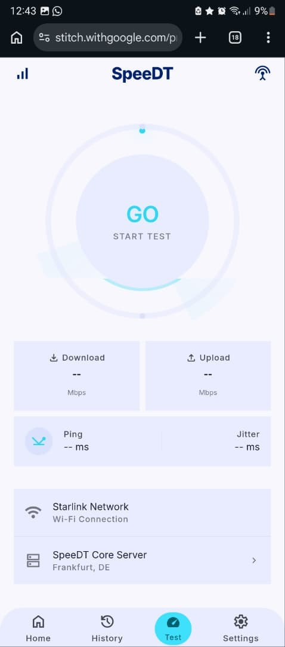
Figure 6: Speed Test Screen Manual Network Speed Test

4.8 Development Challenges
During the development of SpeeDT, our team encountered several challenges. One of the main challenges was ensuring that the application displayed correctly on different screen sizes and devices while maintaining a consistent user experience. We also had to design a navigation system that allowed users to move easily between screens without confusion.
Another challenge was presenting technical network information in a simple and understandable way. Since the application targets both regular users and technical users, we had to balance simplicity with functionality. In addition, performance considerations such as battery consumption and mobile data usage had to be taken into account during development.
These challenges were addressed through continuous testing, interface improvements, and the use of React Native and Expo tools that support cross-platform mobile development.

5. CONCLUSION

Task 5 demonstrates a successful transition from abstract requirements to a concrete, implementable mobile interface. By combining a clean Figma mockup workflow with Expo's cross-platform development infrastructure, the team has produced an interface that directly addresses the real-world constraints of Cameroonian smartphone users. The resulting design is clear, easy to navigate, and highly responsive across device sizes.
The MVVM architectural pattern, TypeScript-typed data models, and modular component structure provide a solid foundation for the remaining development stages. Moving forward, the implementation path will:
- Connect the onboarding and consent flows to secure local SQLite storage for persistent permission state.
- Wire the real-time dashboard to live device telemetry streams via platform-specific native hooks (WorkManager on Android, BackgroundTasks on iOS).
- Complete the offline queue synchronisation layer to manage data transfers to the cloud backend when connectivity is restored.
- Integrate the event-driven feedback prompt overlay (QoE rating modal) triggered by background network degradation events.

REFERENCES

- Figma Design by group 4 members
- Agence de Régulation des Télécommunications (ART) Cameroon. Regulatory Framework for Mobile Data Collection and Subscriber Privacy.
- Frontend Source Code by Group 4.
- CEF440 Group 4 Task 3 Report: Software Requirements Specification (SRS) QoE Mobile Network Monitoring Application. University of Buea, 2025.
- CEF440 Group 4 Task 4 Report: System Modelling and Design. University of Buea, 2025.
- Martin, R. C. (2017). Clean Architecture: A Craftsman's Guide to Software Structure and Design. Prentice Hall.
- React Native Documentation. Cross-Platform Mobile Development: Android and iOS APIs. Available at: https://reactnative.dev
- Expo Documentation. Managed Workflow and SDK Telemetry Guides. Available at: https://docs.expo.dev
- NativeWind Documentation. Tailwind CSS for React Native. Available at: https://www.nativewind.dev

